ORTHOPAEDIC INSTRUMENTS
Bone Holding Forceps
Heygrove's Bone Holding Forceps with Speed Lock
Intended Use
Heygrove's bone holding forceps with speed lock are reduction and stabilisation instruments used to grasp and maintain the position of bone fragments during fracture reduction and plate or nail fixation in veterinary orthopaedic surgery. The speed-lock ratchet mechanism holds the grip without sustained hand pressure, freeing the surgeon to use both hands for fixation. | [Missing: Heygrove's Bone Holding Forceps with Speed Lock.jpg]
Function
Sturdy serrated jaws close onto the bone fragment and are locked in position by a speed-lock ratchet that engages progressively as the handles close. The ratchet holds the reduction against muscle forces without requiring continued manual grip, allowing the surgeon to simultaneously drill, tap and insert fixation implants.
Advantages
Hands-Free Fragment Hold: The speed-lock maintains fracture reduction independently, freeing both surgical hands to place drill guides, insert screws or apply a plate — critical in single-surgeon orthopaedic settings and complex multi-implant fixation.
Atraumatic Jaw Profile: Point or serrated jaws grip cortex without shattering fragile fracture lines, preserving the fracture geometry needed for accurate anatomical reduction essential to normal limb function restoration.
FAQ
Q: How are the forceps positioned without disrupting the fracture reduction?
A: Approach from the least-obstructed cortical surface, clamp distal to the fracture line on each fragment, and verify reduction radiographically or visually before engaging the speed lock.
Q: Can Heygrove's forceps be used on all long bones?
A: They are designed for medium and large bones; on very small bones or fine cortices (feline radius/ulna) lighter reduction forceps with finer jaw profiles are preferred to avoid cortex damage.

ORTHOPAEDIC INSTRUMENTS
Bone Holding Forceps
Lowman Bone Clamp Double Jaw
Intended Use
The Lowman bone clamp double jaw is a stable, self-retaining instrument used to hold two bone fragments together in correct reduction during plating or arthrodesis procedures. Its double-jaw configuration grips both cortices of a bone simultaneously, maintaining alignment while both hands are free for implant insertion. | 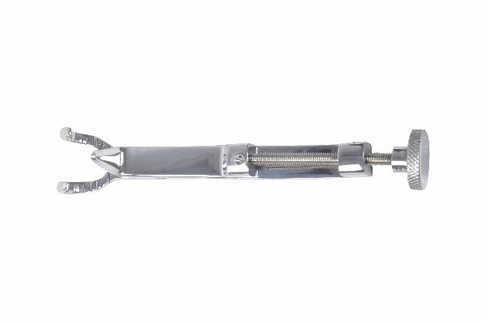
Function
Two independently adjustable sets of serrated jaws are mounted on a frame. Each jaw set grips one bone fragment or one cortex of a joint. A central thumb-nut tightens both jaw sets simultaneously, drawing the fragments together and maintaining reduction. The frame allows the construct to remain stable on the surgical table without hand support.
Advantages
Simultaneous Bilateral Grip: The double-jaw design grips both bone fragments or both joint surfaces at once, distributing clamping force evenly and preventing rotational malalignment that single-jaw clamps cannot reliably control in complex fracture patterns.
Arthrodesis-Ready Stability: The frame and thumb-nut mechanism apply controlled compression across arthrodesis sites in the carpus, tarsus and stifle, maintaining bone-on-bone contact throughout plate and screw fixation.
FAQ
Q: Is the Lowman clamp suitable for fine cortical bones in cats?
A: The double-jaw Lowman clamp is designed for larger bones; lighter spring-loaded bone clamps are preferred for feline cortical thickness to avoid crushing fragile bone segments.
Q: Can the double jaw clamp apply compression across a fracture?
A: Yes — tightening the thumb-nut after jaw engagement progressively closes the fracture gap, achieving interfragmentary compression prior to plate application.

ORTHOPAEDIC INSTRUMENTS
Bone Holding Forceps
Malleolar Forceps – Pointed with Speed Lock
Intended Use
Malleolar forceps with pointed tips and speed lock are precision reduction instruments used to grip and stabilise small bone fragments, particularly malleolar, condylar and juxta-articular fracture pieces in veterinary orthopaedic surgery. The pointed tips penetrate cortex for firm grip on small fragments too small for standard bone forceps. | 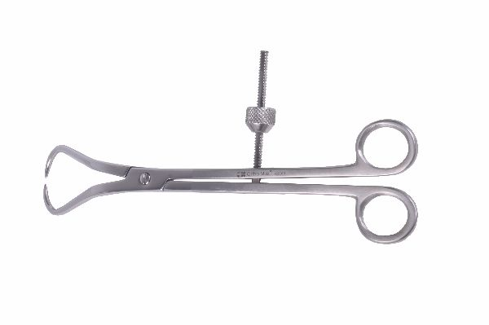
Function
Pointed tips pierce the cortex of small bone fragments, engaging the spongy cancellous bone beneath for a non-slip grip. The speed-lock ratchet maintains the reduction, while the slim handle profile allows placement in the narrow access corridors around joints where standard forceps are too large to manoeuvre.
Advantages
Small Fragment Control: The cortex-penetrating pointed tips secure fragments as small as 5–8 mm that would slip from serrated flat jaws, enabling accurate reduction of small condylar chips, lateral malleolar pieces and apophyseal avulsions.
Speed Lock for Free-Handed Fixation: Once pointed tips are seated and the lock engaged, the surgeon inserts lag screws or tension band wires without maintaining manual grip — essential for placing fixation perpendicular to the fracture plane in small joint spaces.
FAQ
Q: Do the pointed tips leave permanent cortical holes?
A: Yes, small cortical puncture holes are left; these are inconsequential and fill with callus during healing but should be sited away from planned screw tracks to preserve bone stock.
Q: What joint fractures are malleolar forceps most useful for?
A: Lateral and medial malleolar fractures of the tarsus, condylar fractures of the femur and humerus, and tibial plateau fractures are the most common indications in small animal orthopaedics.

ORTHOPAEDIC INSTRUMENTS
Bone Holding Forceps
Patella Clamp
Intended Use
The patella clamp is a specialised reduction instrument used to compress and hold patella fracture fragments together during tension band wire or lag screw fixation in dogs and cats. It applies controlled compression across the fracture plane while the surgeon installs K-wires and tension band wire for definitive fixation. | 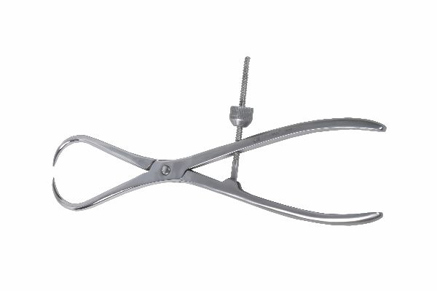
Function
Two broad, curved jaw faces conform to the naturally convex patellar contour and apply uniform compression across the full fracture surface. A central ratchet screw progressively draws the jaws together, compressing the fragments without the point-loading that risks comminution from small-jaw instruments on the patella's cancellous bone.
Advantages
Contoured Jaw Design: Curved jaw faces match patellar anatomy, distributing compression evenly across the entire fragment interface — preventing the cortical crack propagation that pointed clamps cause when applied to the superficial patellar cortex.
Maintains Reduction During Wire Passage: With the clamp holding the reduction, K-wires are drilled through both fragments in accurate parallel orientation without fragments shifting, ensuring the tension band construct applies symmetric compression through the full range of joint motion.
FAQ
Q: Can the patella clamp be used for other sesamoid bones?
A: It can be adapted for large fabella or accessory carpal bone fractures in dogs, though purpose-designed mini clamps may be more appropriate for very small sesamoid fragments.
Q: What is the typical K-wire size for patellar tension band fixation in dogs?
A: 1.6 mm K-wires are standard for medium and large breed dogs; 1.0–1.2 mm wires are used in small breeds and cats, paired with 0.8–1.0 mm figure-of-eight tension band wire.

ORTHOPAEDIC INSTRUMENTS
Bone Holding Forceps
Reduction Bone Holding Forceps
Intended Use
Reduction bone holding forceps are standard pointed-jaw reduction instruments used in veterinary orthopaedics to grip, align and hold diaphyseal bone fragments during fracture reduction prior to plate or nail fixation. They are among the most frequently used instruments in any small animal long bone fracture repair. | 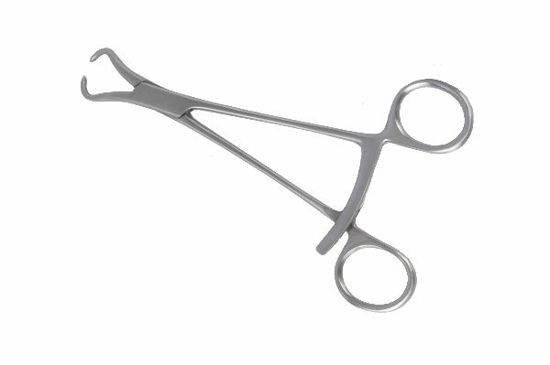
Function
Pointed tips penetrate cortex to anchor the forceps on each major fragment. Closing the handles pulls the fragments into alignment while the surgeon confirms reduction visually or by palpation. The ratchet or speed-lock maintains reduction while the surgeon's hands are freed for implant application.
Advantages
Reliable Cortical Grip: Cortex-penetrating tips prevent the instrument from slipping off the bone surface during reduction manoeuvres, even when periosteum is stripped from the fragment — a situation where flat-jawed clamps lose grip.
Simultaneous Reduction and Fixation: The speed lock maintains fracture alignment while both hands work on plate bending, drill guide placement and screw insertion, dramatically reducing the time between reduction and fixation.
FAQ
Q: Where are reduction forceps positioned relative to the plate?
A: Forceps are typically placed on the cortex opposite the plate surface to avoid interference with plate positioning; one forceps per major fragment, positioned to maintain both coronal and sagittal alignment.
Q: Can reduction forceps damage cortex during prolonged use?
A: Prolonged high-compression gripping can cause minor cortical impressions; re-position if operative time exceeds 20–30 minutes to prevent localised cortical necrosis under the forceps tips.

ORTHOPAEDIC INSTRUMENTS
Bone Holding Forceps
Reduction Bone Holding Forceps 1
Intended Use
This variant reduction bone holding forceps features a modified jaw geometry offering an enhanced grip angle for specific fracture configurations in veterinary patients. The design allows reduction to be maintained at a different approach angle, useful in limited-access exposures such as minimally invasive plate osteosynthesis (MIPO) in small animals. | 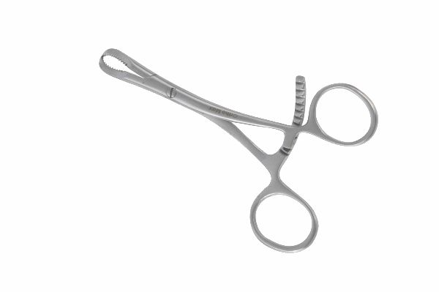
Function
The angled jaw approach allows engagement of fracture fragments through limited skin incisions or from specific anatomical directions where standard forceps cannot be placed without obstructing the surgeon's view or plate application. The speed lock mechanism maintains stable reduction once the optimal position is achieved.
Advantages
Alternative Approach Angle: Modified jaw orientation allows forceps engagement from medial or posterior surfaces that standard forceps cannot reach in deep wounds or MIPO procedures, giving the surgeon options in complex anatomical situations.
Compact Handle Profile: Reduced handle bulk compared to standard reduction forceps allows placement in crowded surgical fields without obstructing the assistant's instrument handling or the surgeon's direct vision of the fracture line.
FAQ
Q: How does this variant differ from standard reduction forceps?
A: The jaw approach angle and tip geometry are modified to provide better access in specific anatomical locations; both instruments serve the same purpose of fragment stabilisation during fixation.
Q: Are these forceps specific to a bone type?
A: They are most useful for distal femoral, proximal tibial and humeral fractures where standard forceps placement conflicts with plate positioning — but can be adapted to other fracture configurations.

ORTHOPAEDIC INSTRUMENTS
Bone Holding Forceps
Reduction Forceps with Speed Lock – Serrated Jaws
Intended Use
Reduction forceps with speed lock and serrated jaws are bone fragment gripping instruments used for larger fracture fragments where serrated jaw faces provide a broader, distributed grip without cortex puncture. They are preferred for metaphyseal and cancellous bone fragments that are too soft for pointed-tip cortical penetration. | 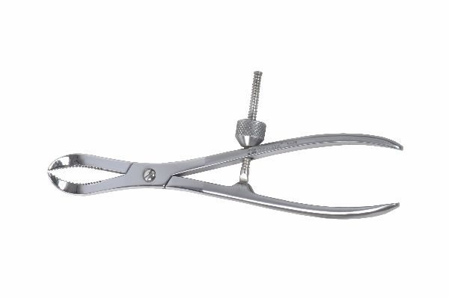
Function
Broadly serrated jaw faces grip the cortical surface over a wide area, preventing the fragment from rotating within the jaws during reduction. The speed lock ratchet progressively tightens the serrated grip as handles are closed, while the spring mechanism returns the jaws to open position when the ratchet is released for repositioning.
Advantages
Cortex-Preserving Serrated Grip: Serrations grip without penetrating the cortex, preventing puncture holes in cancellous metaphyseal bone where cortex is thin — protecting bone stock that is critical for screw purchase in periarticular fixation.
Wide-Surface Grip Stability: The broad serrated contact area prevents fragment rotation during reduction, particularly valuable for large comminuted metaphyseal fragments that tend to spin or angulate within pointed-tip forceps.
FAQ
Q: When are serrated jaw forceps preferred over pointed-tip forceps?
A: In metaphyseal, epiphyseal and cancellous bone fractures where cortex is too thin for tip penetration, and in situations where cortex integrity must be preserved for screw purchase near the fracture site.
Q: Can serrated jaws slip off dense cortical bone?
A: On smooth, dry cortex the serrations may slip; periosteal stripping and light scoring of the cortex surface with a periosteal elevator improves grip before applying serrated jaw forceps.

ORTHOPAEDIC INSTRUMENTS
Bone Holding Forceps
Self-Centering Forceps with Speed Lock
Intended Use
Self-centering bone holding forceps with speed lock automatically centre the fracture fragments relative to each other as the jaws close, providing coaxially aligned reduction without the need for manual adjustment. They are particularly valuable in cylindrical long bone fractures where rotational alignment is as important as axial alignment. | 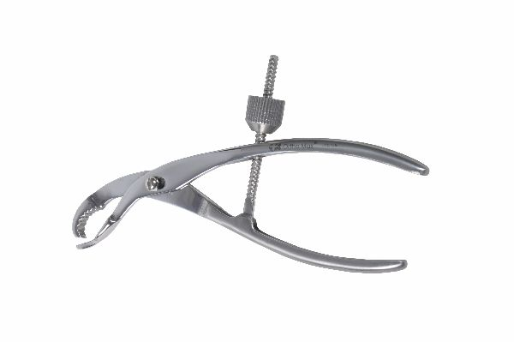
Function
The symmetric jaw design ensures that as the handles are closed, both jaw tips travel inward equally and simultaneously. This geometry draws opposite cortical surfaces toward the jaw midpoint, centering the bone axis between the jaws and producing automatic correction of minor rotational or lateral displacement as the instrument closes.
Advantages
Automatic Fracture Centring: The self-centering mechanism eliminates the need for repeated manual repositioning of forceps to achieve alignment, saving significant operative time especially in oblique fractures where manual alignment is repeatedly lost when instruments are adjusted.
Reproducible Reduction Quality: The symmetric jaw movement provides consistent, reproducible fracture reduction between cases, reducing surgeon-to-surgeon variability in reduction quality — an important factor in training environments.
FAQ
Q: Are self-centering forceps useful for all fracture types?
A: They are most effective for transverse and short oblique diaphyseal fractures; highly comminuted fractures require individual fragment repositioning that self-centering instruments cannot manage automatically.
Q: How is the speed lock released without losing the reduction?
A: Apply a slight compressive force through the handles before pressing the release to prevent the spring from springing the jaws open abruptly and displacing the reduced fracture.

